Week 2 – 13th – 17th January

This week we have continued with Jack Frost and focusing on ice. Jack Frost had frozen his friends, so we were thinking of how we could rescue them. We came up with melting the ice with warm water.
In Maths, we started with odd and even numbers to 10. It’s not an easy concept but the boys and girls worked hard to learn them. We had odd Todd and even Steven to help us.
In the afternoons, we have been looking at hibernation. We focused on hedgehogs. We had a fun activity in making hedgehog bread. We made the dough; let it rise and then made a hedgehog shape and put 2 eyes and baked them. We ate them in the afternoon, and they tasted delicious.
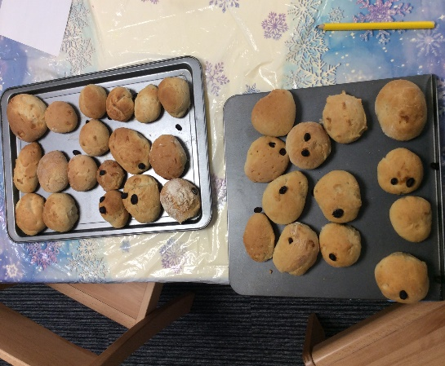
Please send in PE kits as we have started our sessions now.
Many thanks,
EYFS team

