Happy half term to everyone in EYFS! We have had a very busy term, learning all about Winter through our core texts, Here comes Jack Frost, and Snowballs. We have been lucky enough to explore in real snow and ice which has brought the learning to life. As the season has slowly changed, as has our learning journey moved on to begin thinking about Spring, along with the first flowers that appear and which animals are beginning to come out of hibernation. After all the hard work done, a rest is well and truly needed, but we do know that many parents request tasks to complete at home during the half term to continue the learning and we are more than happy to facilitate this! On this document will be a selection of tasks including letter formations, games, and maths related tasks which will support consolidation of previous learning along with preparing them for the term ahead. We ask that you give some of these tasks a go with your child and if you would like to show us what your child has been up to, please take photos and email them to the office, or bring in the work they complete for us to see!
If you require a printed copy of these tasks, please let any member of the EYFS team know by Friday and this can be printed for you.
All the best
The EYFS team
Game link suggestions:
- https://www.topmarks.co.uk/phonics/balloon-phonics-cvc-game CVC words
- https://www.starfall.com/h/word-machines/ CVC words
- https://www.topmarks.co.uk/maths-games/robot-more-or-less Maths game
- https://www.topmarks.co.uk/addition/addition-to-10 Maths game

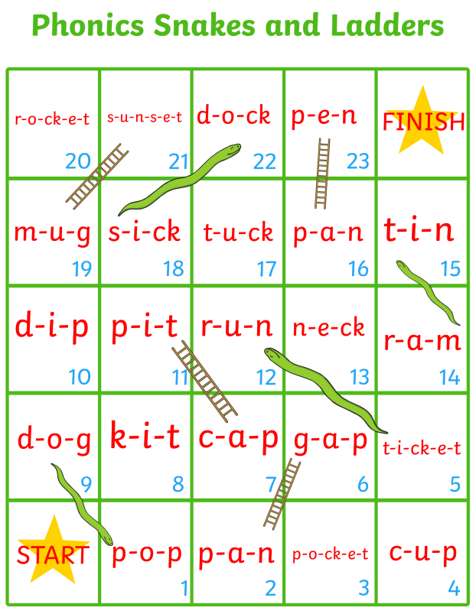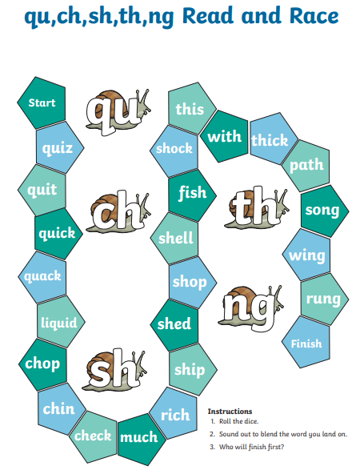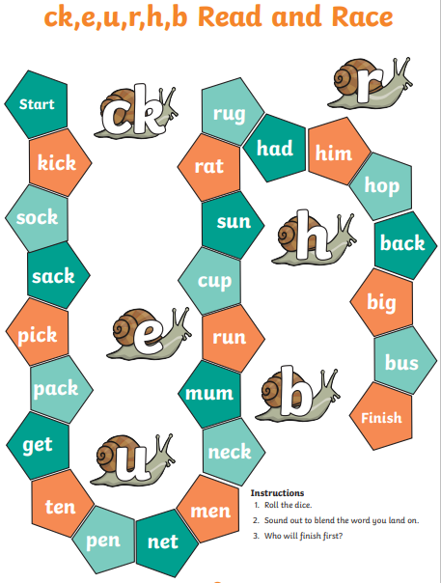
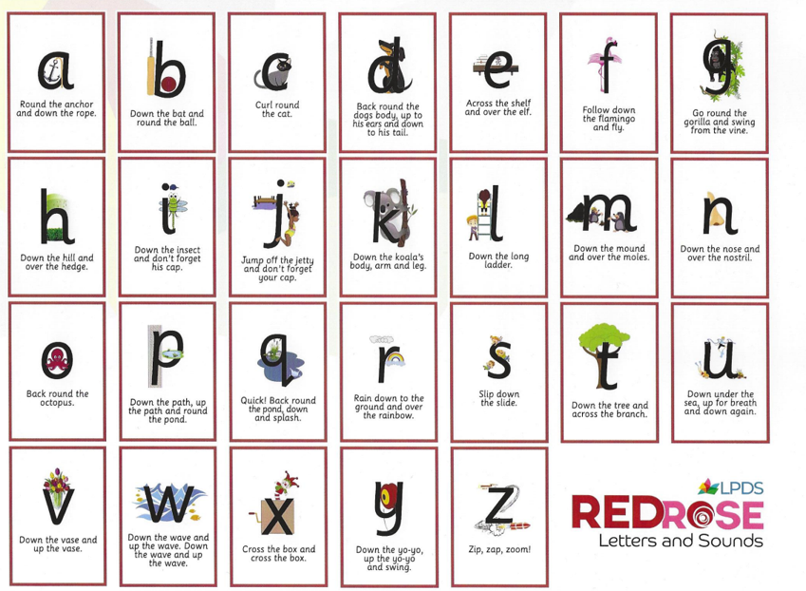
Here is our letter formation guide for lower case letters. We are also working on recognition and formation of capital letters at school, so it would be valuable for you to look at this with your child.
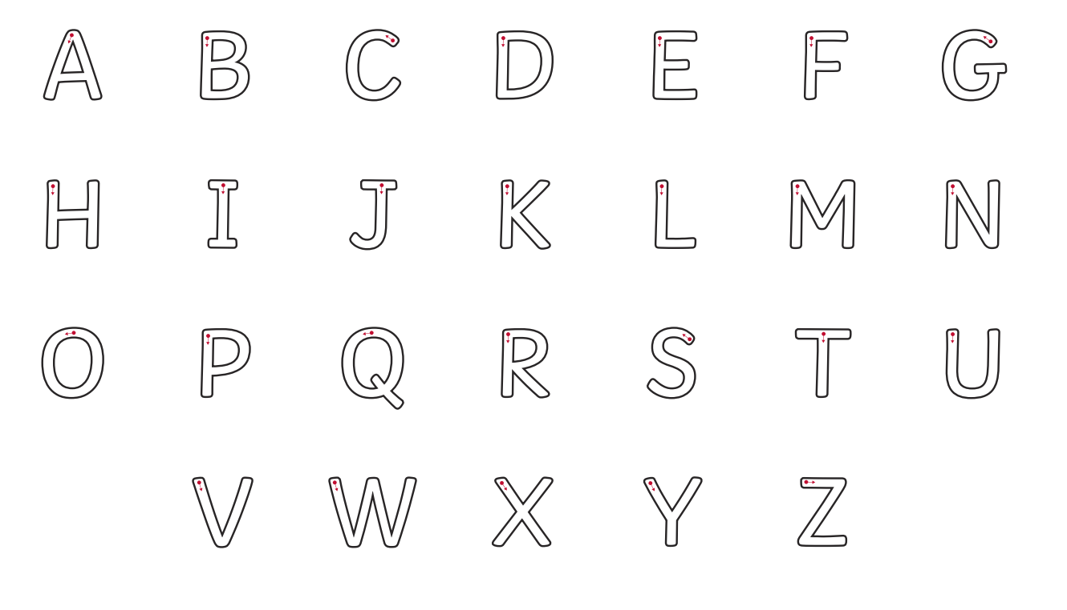

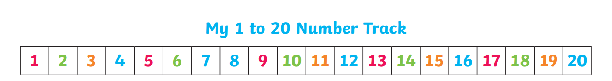
In EYFS, we focus mainly on knowing how to form, make and subitise up to 10 however, we also are required to be able to count up to and backwards from 20 along with recognizing these numbers. It would be amazing if you could spend some time on those numbers above 10 ready for our new term!
